KPI’s

1. **Total Loan Applications**

SELECT COUNT(id) AS total_loan_application FROM bank_db;



1. **MTD Loan Applications**

**SELECT COUNT(id) AS MTD_total_loan_application FROM bank_db**

**WHERE EXTRACT(MONTH FROM issue_date) = 12**

**AND EXTRACT(YEAR FROM issue_date) = 2021;**



1. **Month on Month Loan Applications**

**SELECT COUNT(id) AS PMTD_total_loan_application FROM bank_db**

**WHERE EXTRACT(MONTH FROM issue_date) = 11**

**AND EXTRACT(YEAR FROM issue_date) = 2021;**

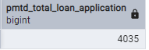

1. **Total funded Amount**

**SELECT SUM(loan_amount) AS total_funded_amount FROM bank_db;**



1. **MTD Total funded amount**

**SELECT SUM(loan_amount) AS MTD_total_funded_amount FROM bank_db**

**WHERE EXTRACT(MONTH FROM issue_date) = 12**

**AND EXTRACT(YEAR FROM issue_date) = 2021;**



1. **Previous Month total funded Amount**

**SELECT SUM(loan_amount) AS PMTD_total_funded_amount FROM bank_db**

**WHERE EXTRACT(MONTH FROM issue_date) = 11**

**AND EXTRACT(YEAR FROM issue_date) = 2021;**



1. **Total Amount Received**

**SELECT SUM(total_payment) AS total_amount_received FROM bank_db;**



1. **MTD total Amount received**

**SELECT SUM(total_payment) AS MTD_total_amt_received FROM bank_db**

**WHERE EXTRACT(MONTH FROM issue_date) = 12**

**AND EXTRACT(YEAR FROM issue_date) = 2021;**

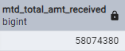

1. **PMTD total Amount received**

**SELECT SUM(total_payment) AS PMTD_total_amt_received FROM bank_db**

**WHERE EXTRACT(MONTH FROM issue_date) = 11**

**AND EXTRACT(YEAR FROM issue_date) = 2021;**



1. **Average Interest Rate**

**SELECT ROUND(AVG(int_rate)::numeric, 4) * 100 AS Avg_Int_rate FROM bank_db;**



1. **Current Month Avg Interest Rate**

**SELECT ROUND(AVG(int_rate)::numeric, 4) * 100 AS MTD_Avg_Int_rate FROM bank_db**

**WHERE EXTRACT(MONTH FROM issue_date) = 12**

**AND EXTRACT(YEAR FROM issue_date) = 2021;**

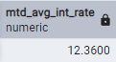

1. **Previous Month Avg Interest Rate**

SELECT ROUND(AVG(int_rate)::numeric, 4) * 100 AS PMTD_Avg_Int_rate FROM bank_db

WHERE EXTRACT(MONTH FROM issue_date) = 11

AND EXTRACT(YEAR FROM issue_date) = 2021;

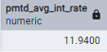

1. **Average Debt to Income Ratio (DTI)**

SELECT ROUND(AVG(dti)::NUMERIC, 4) * 100 AS Avg_DTI FROM bank_db;



1. **Current Month Avg DTI**

SELECT ROUND(AVG(dti)::NUMERIC, 4) * 100 AS MTD_Avg_DTI FROM bank_db

WHERE EXTRACT(MONTH FROM issue_date) = 12

AND EXTRACT(YEAR FROM issue_date) = 2021;



1. **Previous Month Avg DTI**

SELECT ROUND(AVG(dti)::NUMERIC, 4) * 100 AS PMTD_Avg_DTI FROM bank_db

WHERE EXTRACT(MONTH FROM issue_date) = 11

AND EXTRACT(YEAR FROM issue_date) = 2021;



1. **Good Loan %**

SELECT

(COUNT(CASE WHEN loan_status = 'Fully Paid' OR loan_status = 'Current' THEN id END) * 100)

/

COUNT(id) AS Good_Loan_percentage

FROM bank_db;



1. **Good Loan Applications**

**SELECT COUNT(*) AS Good_loan_Applications FROM bank_db**

**WHERE loan_status = 'Fully Paid'**

**OR loan_status = 'Current';**

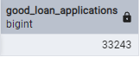

1. **Good Loan Funded Amount**

**SELECT SUM(loan_amount) AS Good_Loan_funded_Amt**

**FROM bank_db**

**WHERE loan_status = 'Fully Paid' OR loan_status = 'Current';**

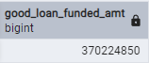

1. **Good Loan Total Received Amount**

**SELECT SUM(total_payment) AS Good_Loan_Total_Received_Amt**

**FROM bank_db**

**WHERE loan_status = 'Fully Paid' OR loan_status = 'Current';**



1. **Total Bad Loan %**

**SELECT**

**(COUNT(CASE WHEN loan_status = 'Charged Off' THEN id END) * 100.0)**

**/**

**COUNT(id) AS Bad_Loan_percentage**

**FROM bank_db;**



1. **Bad Loan Applications**

**SELECT COUNT(id) AS Bad_Loan_Applications FROM bank_db**

**WHERE loan_status = 'Charged Off';**

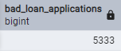

1. **Bad Loan Funded Amount**

**SELECT SUM(loan_amount) AS Bad_loan_funded_amt FROM bank_db**

**WHERE loan_status = 'Charged Off';**

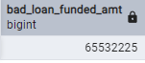

1. **Total bad loan amount received**

**SELECT SUM(Total_payment) AS bad_loan_amt_received FROM bank_db**

**WHERE loan_status = 'Charged Off';**

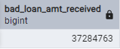

1. **Loan Status Grid View**

**SELECT**

**loan_status,**

**COUNT(id) AS total_applications,**

**SUM(Total_payment) AS total_amt_received,**

**SUM(loan_amount) AS total_funded_amt,**

**AVG(int_rate * 100) AS interest_rate,**

**AVG(dti * 100) AS DTI**

**FROM bank_db**

**GROUP BY loan_status;**

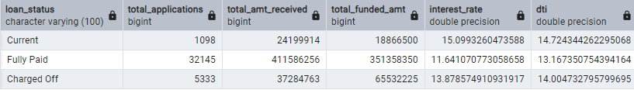

1. **Month to date loan Status grid view**

**SELECT**

**loan_status,**

**SUM(total_payment) AS MTD_total_amt_received,**

**SUM(loan_amount) AS MTD_total_funded_amt**

**FROM bank_db**

**WHERE EXTRACT(MONTH FROM issue_date) = 12**

**GROUP BY loan_status;**

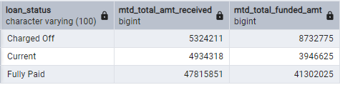

1. **Month trends by Issue Date**

**SELECT**

**TO_CHAR(issue_date, 'Month') AS Month_name,**

**COUNT(id) AS total_loan_applications,**

**SUM(loan_amount) AS total_funded_amt,**

**SUM(total_payment) AS total_received_amt**

**FROM bank_db**

**GROUP BY Month_name**

**ORDER BY MIN(issue_date);**

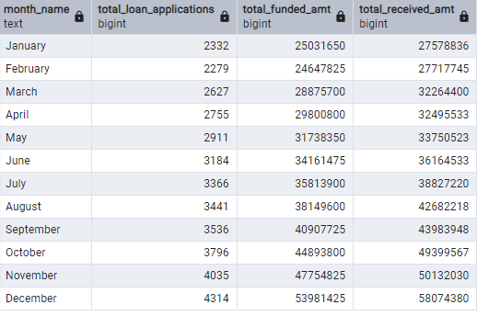

1. **Regional Analysis By State**

**SELECT**

**address_state,**

**COUNT(id) AS total_loan_applications,**

**SUM(loan_amount) AS total_funded_amt,**

**SUM(total_payment) AS total_received_amt**

**FROM bank_db**

**GROUP BY address_state**

**ORDER BY address_state;**

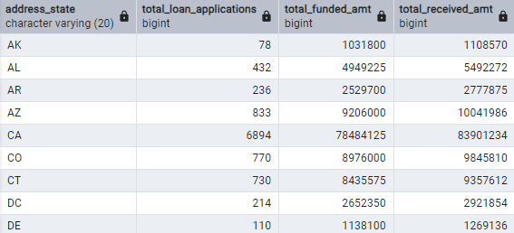

1. **Loan Terms analysis**

**SELECT**

**term,**

**COUNT(id) AS total_loan_applications,**

**SUM(loan_amount) AS total_funded_amt,**

**SUM(total_payment) AS total_received_amt**

**FROM bank_db**

**GROUP BY term**

**ORDER BY term DESC;**

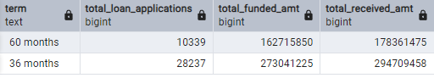

1. **Employee Length Analysis**

**SELECT**

**emp_length,**

**COUNT(id) AS total_loan_applications,**

**SUM(loan_amount) AS total_funded_amt,**

**SUM(total_payment) AS total_received_amt**

**FROM bank_db**

**GROUP BY emp_length**

**ORDER BY emp_length DESC;**

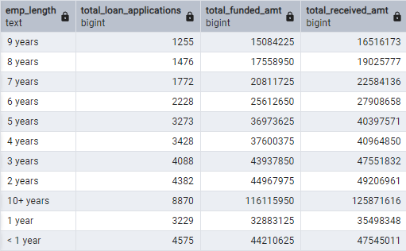

1. **Loan Purpose Analysis**

**SELECT**

**purpose,**

**COUNT(id) AS total_loan_applications,**

**SUM(loan_amount) AS total_funded_amt,**

**SUM(total_payment) AS total_received_amt**

**FROM bank_db**

**GROUP BY purpose**

**ORDER BY total_loan_applications DESC;**

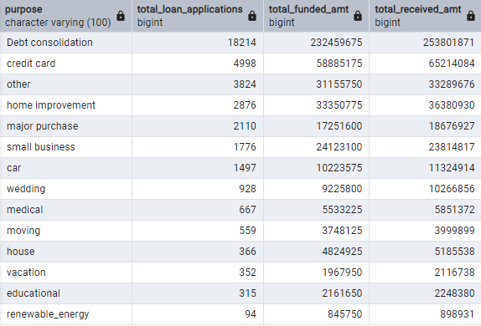

1. **Home Ownership Analysis**

**SELECT**

**home_ownership,**

**COUNT(id) AS total_loan_applications,**

**SUM(loan_amount) AS total_funded_amt,**

**SUM(total_payment) AS total_received_amt**

**FROM bank_db**

**GROUP BY home_ownership**

**ORDER BY total_loan_applications DESC;**

